**Introduction**

***Motivation for this project***

The main theme and dataset were proposed to me by my Professor. Since I have

some interest in the subject matter and video game industry is a big and

fast-growing field, I’ve agreed to that proposal. That’s how it began.

***Research questions***

In this project I will try to answer three questions based on video game data

collected mostly from Steam (digital distribution platform) in 2016:

* *“Are there any associations that can be observed between games that*

*received a Metacritic score and those that didn’t?”*

* *“Is there an association between number of screenshots in game description*

*and the sales of the game?”*

* *“Is there an association between how many copies of the game were sold and the price of the game?”*

***Paper outline***

Introduction (page 1)

Background and Methods (pages 1 - 5)

Data Analysis (pages 5 - 12)

Conclusions (page 13)

Works Cited (page 14)

**Background and Methods**

***Topics of research***

1. *Work of the original authors*

Authors of the dataset I’ll be using did a data analysis of their own.

During their research, they proved that free games do receive more

recommendations on average, compared to non-free games. But free

games do score lower on average (Metacritic score) than non-free

games. Another prediction that they made was that the most

recommended and the highest rated genre is action, but they found

out that the most recommended genre was free to play and, for highest

rated, it was sports instead of action. Final prediction of theirs was that

Metacritic scores are an inverse bell curve when sorted by

recommendation, i.e. lower and higher scoring games would have

more recommendations that games with a middle score. While not

exactly related to their original prediction, they found that pricing

compared to Metacritic scores is mostly uniform and that pricing

compared to user recommendations is also nearly uniform. Those two

facts don’t support the idea of an inverse bell curve, thus most likely

it’s not. In my research I would like to investigate Metacritic score

from perspective of which games received this score and which didn’t

to see if there are any commonalities/associations that could be

observed.

1. *Metacritic score*

Since one of my questions deals with Metacritic score, I had to research how it works and basically dig any information that might be useful in my understanding of it, since it will aid in answering the question(s) later.

Official “About” and “FAQ” pages on Metacritic website turned out to be very useful in my research and cleared out most uncertainties I had about it [1]. Here are my findings:

First, Metacritic website covers virtually all new game releases in United States and other English-speaking territories, as long as they are reviewed by multiple publications (at least four).

There are two main scores on the website: Metacritic score (based on weighted calculation of scores from different publications/critics) and a User score (based on user reviews). User scores are not used in Metacritic score calculation and in contrast to publication/critic reviews, user reviews may be changed down the line (Metacritic only accepts first review from a publication to avoid situations when publication’s score changes down the line by means of potential external pressure on the publication). Also, some of publication/critic reviews might not provide a discrete value for their score, so it’s up to Metacritic staff to assign a numeric value to such reviews. Usually they work in increments of 10 (0-100), but sometimes might fall somewhere in between (for instance: 75).

Speaking of Metacritic score, weightings for it are kept in secret (User

score is not weighted). And lastly, low score for Metacritic score

doesn’t necessarily mean that game is that bad in terms of experience

(but it certainly might); it means that most of publication/critic reviews

were generally negative.

1. *Steam and Steam Spy*

Steam is a digital distribution platform developed by Valve

Corporation for purchasing and playing video games [7]. The Steam

platform is the largest digital distribution platform for PC gaming,

estimated in 2013 to have 75% of the market space [8]. By 2017, users

purchasing games through Steam totaled roughly $4.3 billion,

representing at least 18% of global PC games sales [9]. In terms of

number of games, in March 2017, Steam had about 80-90% of all

games on PC platform (based on number of games in leading

distribution services on the time: around 14K games out of 16K

games on the platform were on Steam) [10].

Steam Spy is a website that uses an application programming interface

(API) to the Steam to estimate the number of sales of software titles

offered by the service. Estimates are made based on the API polling

using profiles from Steam to determine what software titles (primarily

video games) they own and using statistics to estimate overall sales.

Estimates for number of owners and players for specific titles (games)

were taken from this resource and added to the dataset that I’ll be

using.

1. *Finding associations/correlations in game data*

Most sources I found didn’t state any clear questions that they wanted to be answered and were more like articles than scientific papers. Only one paper [2] used regression and some other Data Mining techniques to find correlation between certain game characteristics (genre, tags, price, etc.) and game sales. Author determined that having some successful games behind your belt does help you to succeed with your new game. Also, author determined a set of parameters that influence the sales of games the most (some of them: genres, length of description, launch price, age requirements, presence of multi-player and others). Other sources used more generic analysis techniques, such as comparing averages of different categories [3] [4]. One of the articles I stumbled upon [5], while didn’t really do much in terms of analysis of video games data, provided and interesting outlook on why someone might be interested in doing their own research on video games if they are planning to get into game development or are already one (basically to have a higher chance of success).

***Background reading conclusions***

The most useful and comprehensive information was found for Metacritic score,

which will certainly help me with answering my question. Also, while I found out

that a game receives a Metacritic score when it’s been reviewed by at least four

critics/publishers it keeps my question of trying to find out if there are some

associations to be found in terms of how different game parameters affect game

having a Metacritic score or not.

In terms of research in this area, there is quite a bit of research more based on

implications of gaming in general and more sophisticated studies on specific

aspects of the games. Couldn’t find much in terms of good studies on how

different parameters of the video games correlate/associate with each other. Most

of articles that I found did a more rudimentary analysis – comparing averages of

certain categories or just analyzing distributions of certain parameters. One of the

articles used regression for finding correlation between variables, it might be a

good fit for some of my questions.

Finally, for original analysis on this data set, authors did have a similar style of

question to my question (2) and (3). It was about association between whether a

game is free or not and number of recommendations. Since authors didn’t asses

the question I want to answer, and I haven’t seen my questions answered from

other works on this subject, I’ll keep my questions unchanged.

***Methodology***

1. *Data Collection*

For this project I’m using a preexisting dataset [6]. Most of the data was collected

from Steam via Steam API and some extra data (for instance owner count and

players estimate) was acquired from Steam Spy (service that collects the kind of

data mentioned before from games on Steam). Also, Metacritic score for games

was included in that dataset. For Steam data, it consists of all listings (mostly

games, but also some non-game software) from Steam dating December 12 of

2016.

This dataset most likely is a rather big (around 70-80% of population) non-

random sample of games on PC platform (excluding games that can be emulated

and games that don’t run any more on recent at the time versions of operating

systems). This estimate was made from comparison of number of games on Steam

and some other popular game-distribution services that usually don’t have many

games in common (for instance GOG.com “remakes” many old games to make

them compatible with modern systems, or Uplay releases only Ubisoft (game

publisher) games) [10]. In this comparison around 14,000 games in 2017 was on

Steam and around 2,000 on GOG and Uplay (numbers were taken from [10]).

Finding specific numbers proved to be almost an impossible task, thus I’ll have to

do with these results.

While Steam games most likely represent most games in the population, there are

distribution services with more unique games (like old games from GOG.com and

fan-made or not officially published games) that sway me to think that I should

not generalize my result to all PC games. Because of this I’ll generalize any

results I find only to games on Steam, which will still be enough in my opinion,

since Steam is the most popular digital game-distribution platform and probably,

while can’t represent all games on the platform, most likely represents the

platform that most PC gamers use, which makes it relevant.

Also, speaking of data, original authors [6] indicated that there are quite a few

games that nobody bought and thus never played on Steam – this might result in

big number of outliers or other obstacles and I’ll need to take care of it. If that will

be the case, I’ll try to linearize the relationships between the variable by either

taking the log of the data or taking the square root of it and see which works best.

Another thing that I already noticed – the dataset contains some non-game titles,

they will need to be removed before I move onto the data analysis.

1. *Data Analysis*

- “*Are there any associations that can be observed between games that received a*

*Metacritic score and those that didn’t?*” For this question I’ll probably compare

the averages for different features (those that are numeric) in two different groups

– those that received a Metacritic score and those that didn’t. Also, might look at

the distribution of features for each of the groups, will most likely provide some

more insight into this question.

For my next questions, I decided to focus on descriptive and visual measure (game

screenshots) of the games since those are usually are a part of advertising for the

game and thus will probably have some effect on game sales.

- “*Is there an association between number of screenshots in game description and*

*the sales of the game?”* For this one, most likely I’ll try to use some sort of

regression analysis, to determine if there is any association.

- “*Is there an association between how many copies of the game were sold and the*

*price of the game?*”, for this one, also, regression seems like the most appropriate

choice from what we learned so far in DwD1.

1. *Data Visualization:* All the relevant visualizations will be done in R.

**Data Analysis**

***Question 1***

*“Are there any associations that can be observed between games that received a*

*Metacritic score and those that didn’t?”*

Since the dataset I’m using consists of quite a few variables, I will compare only 4

variables to see if there are any associations between games that have a Metacritic score

and those that don’t. I’ve decided to use number of owners, game price, number of

recommendations, and achievement count as the variables I would like to test. First,

let’s divide our data in two groups by whether a game received or not a Metacritic score:

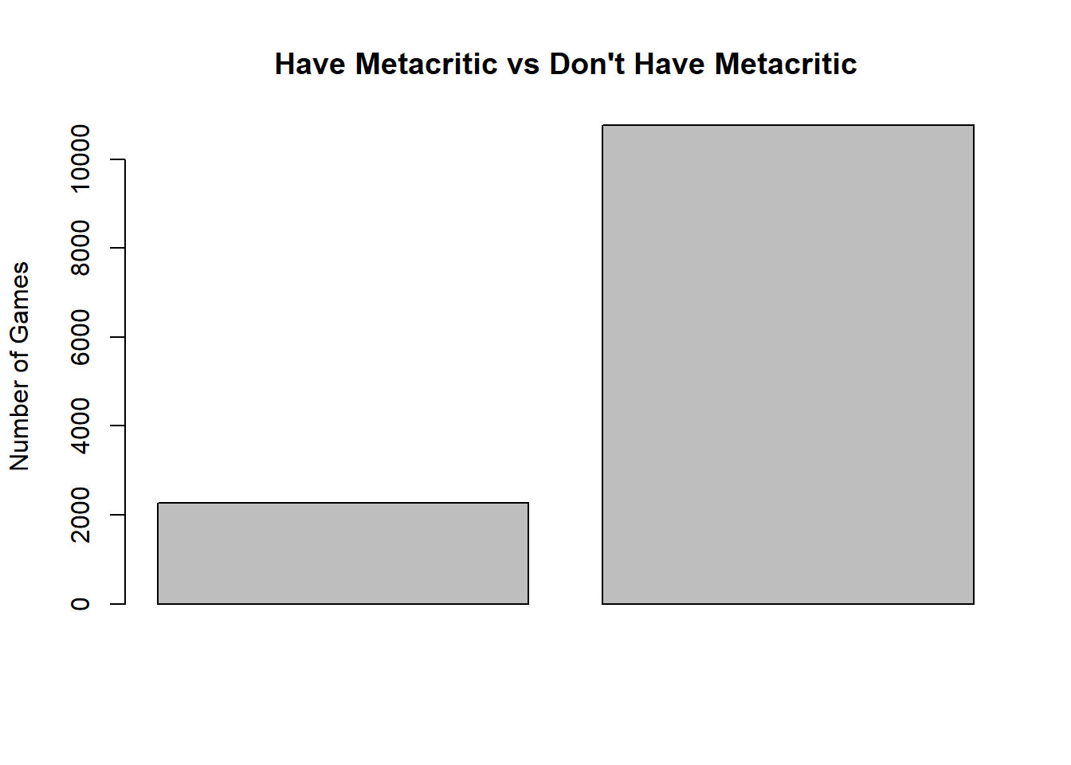

As you can see - majority of games didn’t receive a Metacritic score. Only about 17% of

games received it. Now, let’s look at the means for our selected variables. My prediction is

that there are some distinct differences in values for those variables between the two groups.

First, I tried to use a boxplot but it’s too hard to interpret the plot due to big numbers + many

outliers:

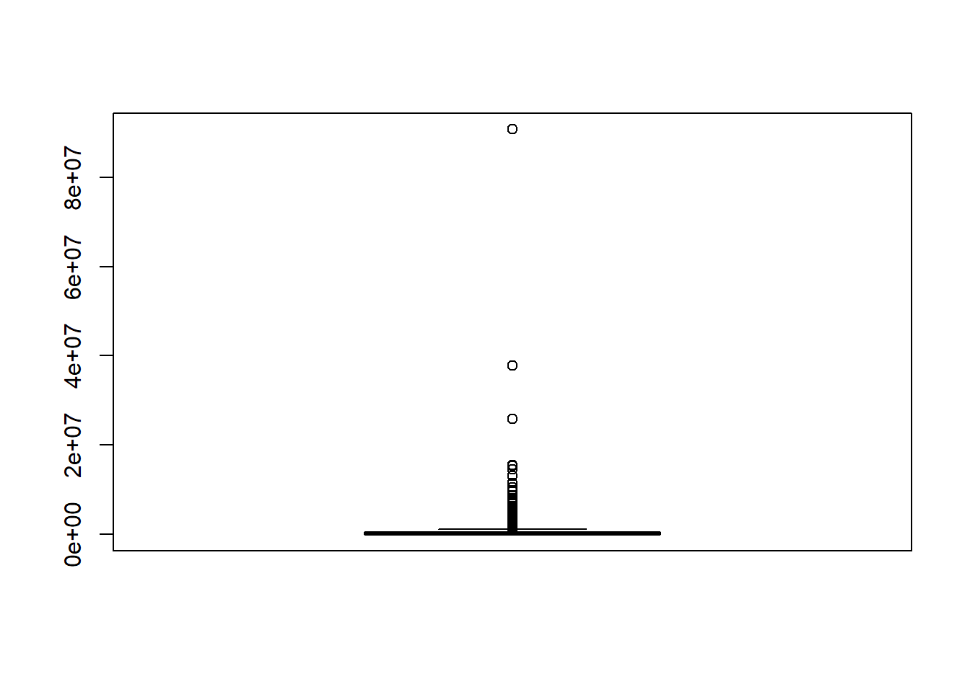

Thus, I decided to use text-based statistical summaries to observe any differences between

our groups:

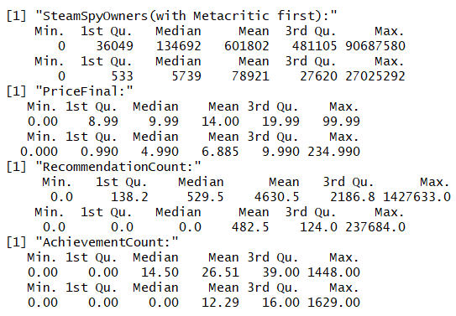

So, let's start with SteamSpyOwners: mean number of owners for games with Metacritic

score is quite a bit higher than the other group. Also, 3rd quartile numbers for both

groups are smaller than the means, indicating that there are quite a few outliers affecting

the average drastically.

For price: mean statistic is about twice as big in group with Metacritic score compared to

one without.

RecommendationCount: mean number of recommendations for the group with the score

is quite a bit bigger comparatively and median for group without Metacritic is 0, which

means that at least 50% of game in that group don't even have a single recommendation.

In terms of number of achievements, at least 50% of games in group without the score

don't have any. Also mean is about twice as big for the group that has the Metacritic

score. Pretty amazed to see the max numbers of achievements, those games are either

pretty deep or "grindy"(when developer forces you to progress slowly, usually with

an option to pay to progress quicker...)

Let's also look on density plots for those variables, to hopefully have some new

perspectives on the data:

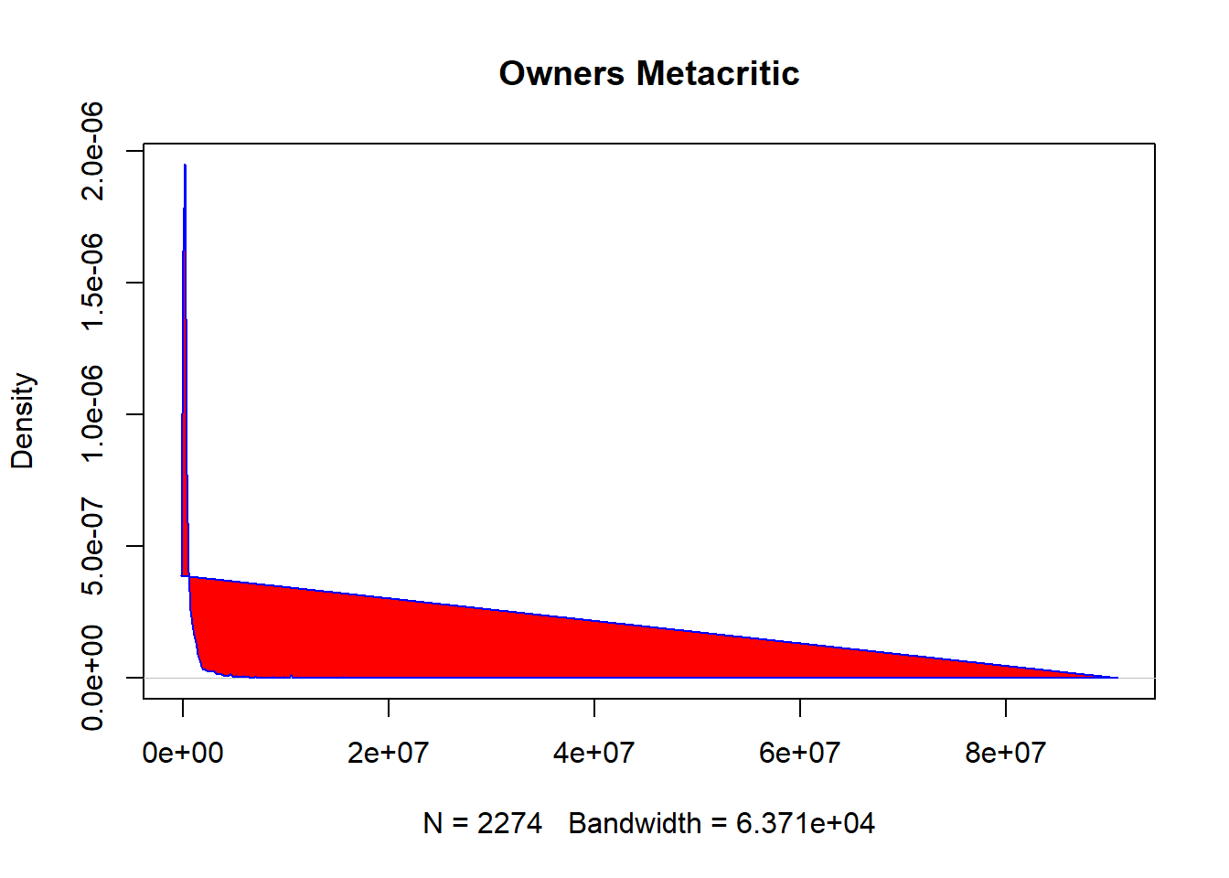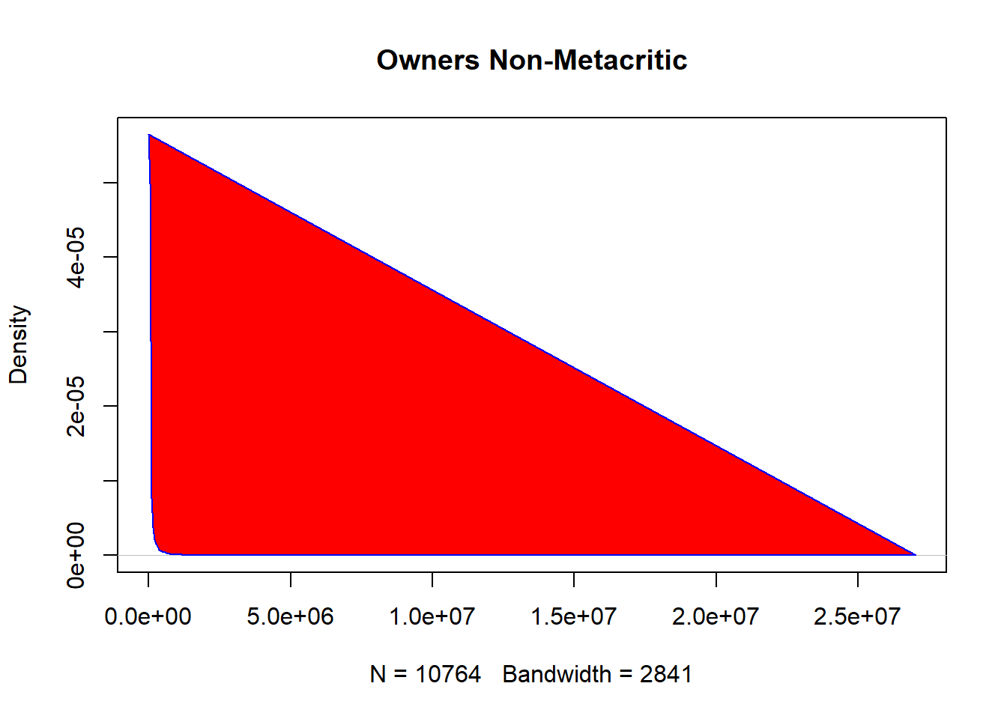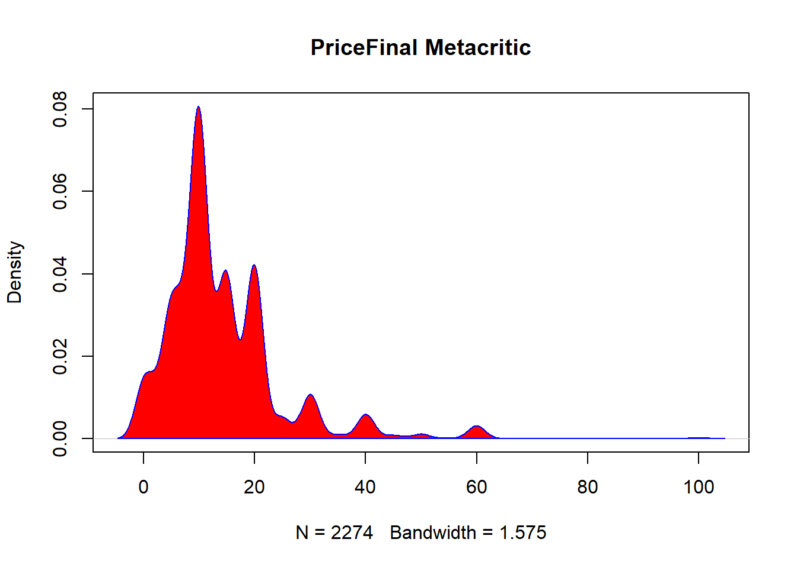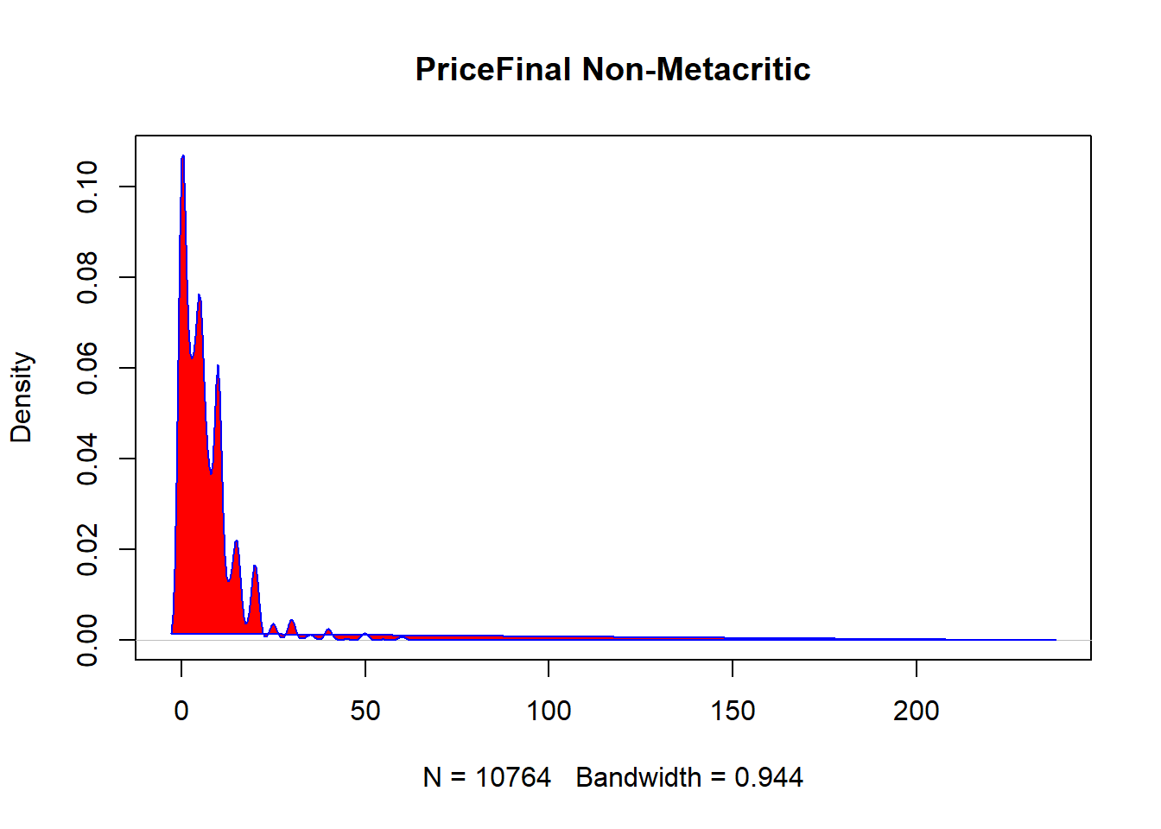

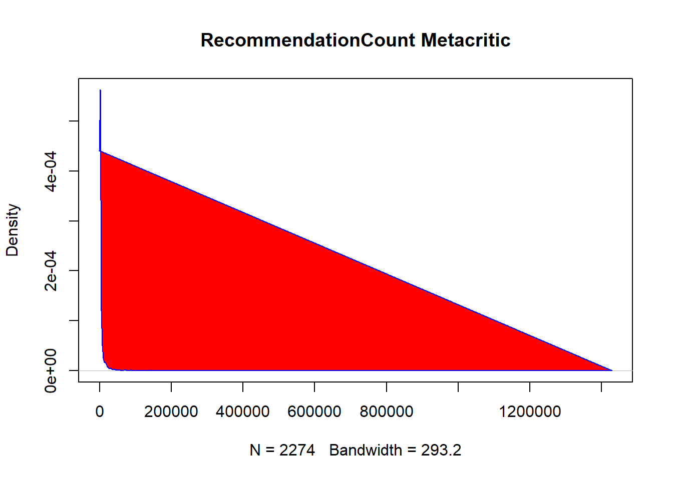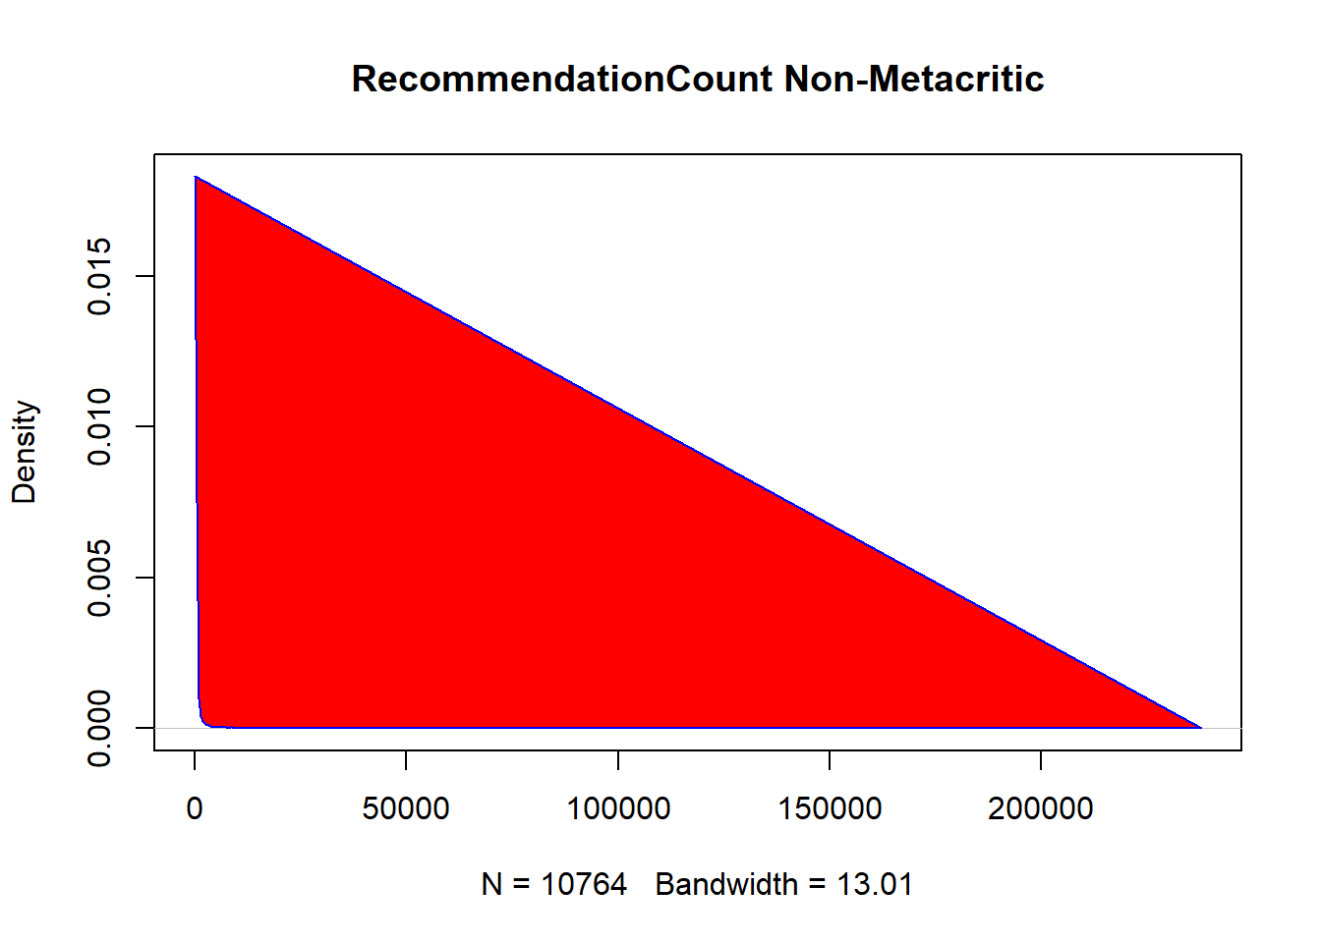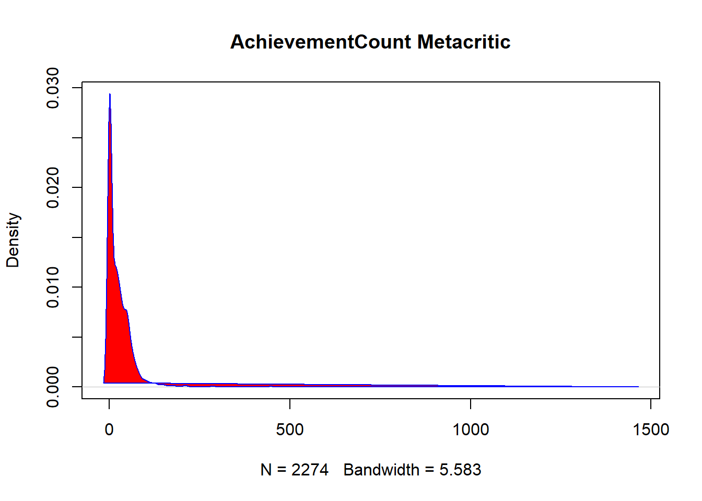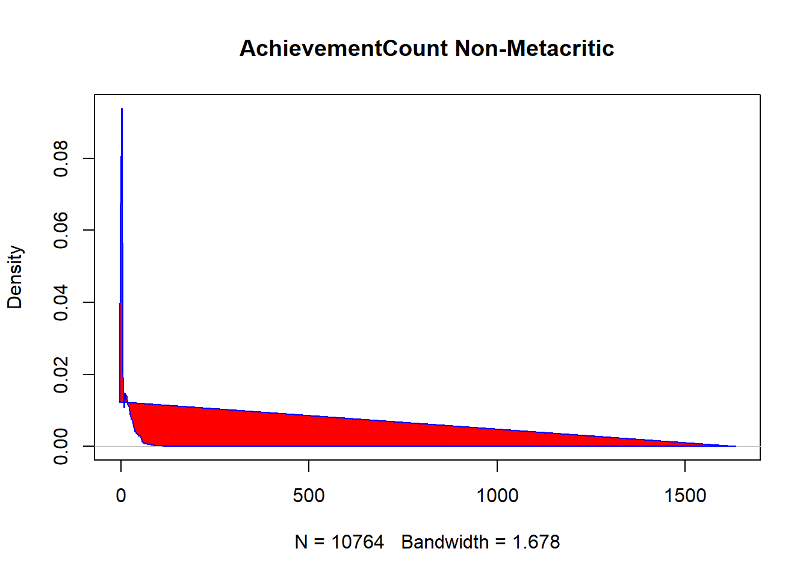

Hmm, well, these graphs didn’t really reveal anything new to me, but still nice to have a

visual representation of what’s going on with the variables.

In conclusion to this question, there are certainly some distinct differences between games that have a Metacritic score and those that don’t, in terms of their sales, price,

recommendations count, and achievements count. This does support my prediction made

earlier.

***Question 2***

*“Is there an association between number of screenshots in game description and the*

*sales of the game?”*

To visualize the relationship, let’s graph a scatterplot of the data first:

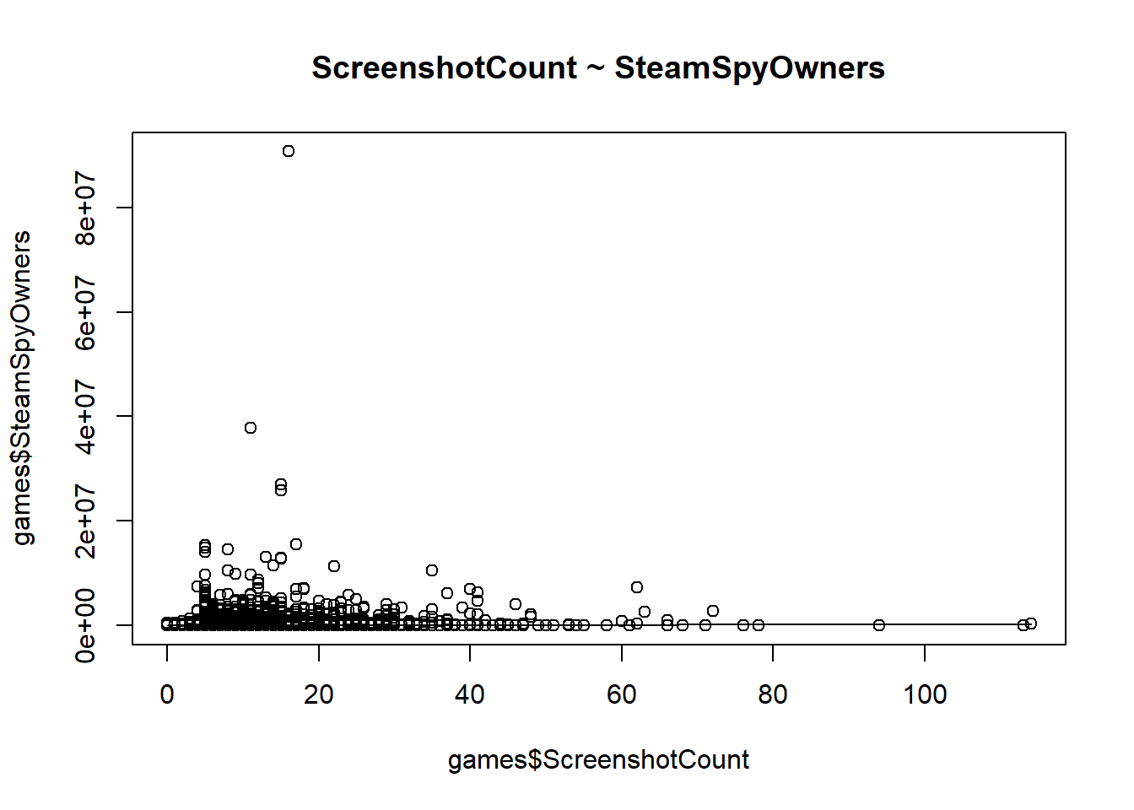

Not much can be seen at that scale, too many outliers. Speaking of which, to see if we

have any outliers (and how many), let’s graph boxplots for both the “ScreenshotCount” and “SteamSpyOwners”:

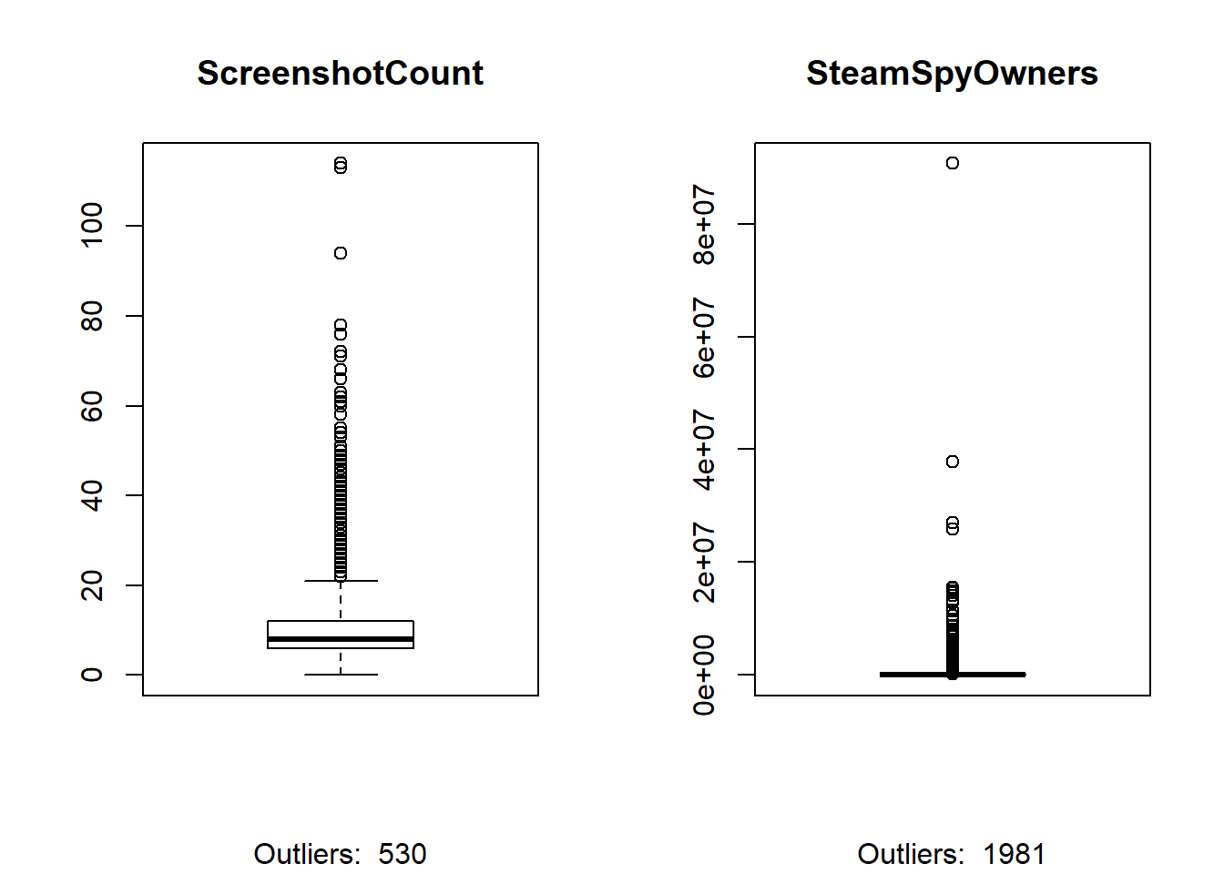

As you can see, we have quite a few outliers. 530(around 4% of the dataset) for number of screenshots for a game, and 1981 (around 15% of the dataset) for number of owners for a game! To proceed with linear regression, we will need to deal with those outliers.

I won’t be getting rid of outliers, since they were collected the same way all the other data was collected (they’re not a mistake) and are significant for the question(s) I want to answer. To help linearize the relationships between the variables, I will transform the data needed into either log or square root of it. Let’s see which will work the best:

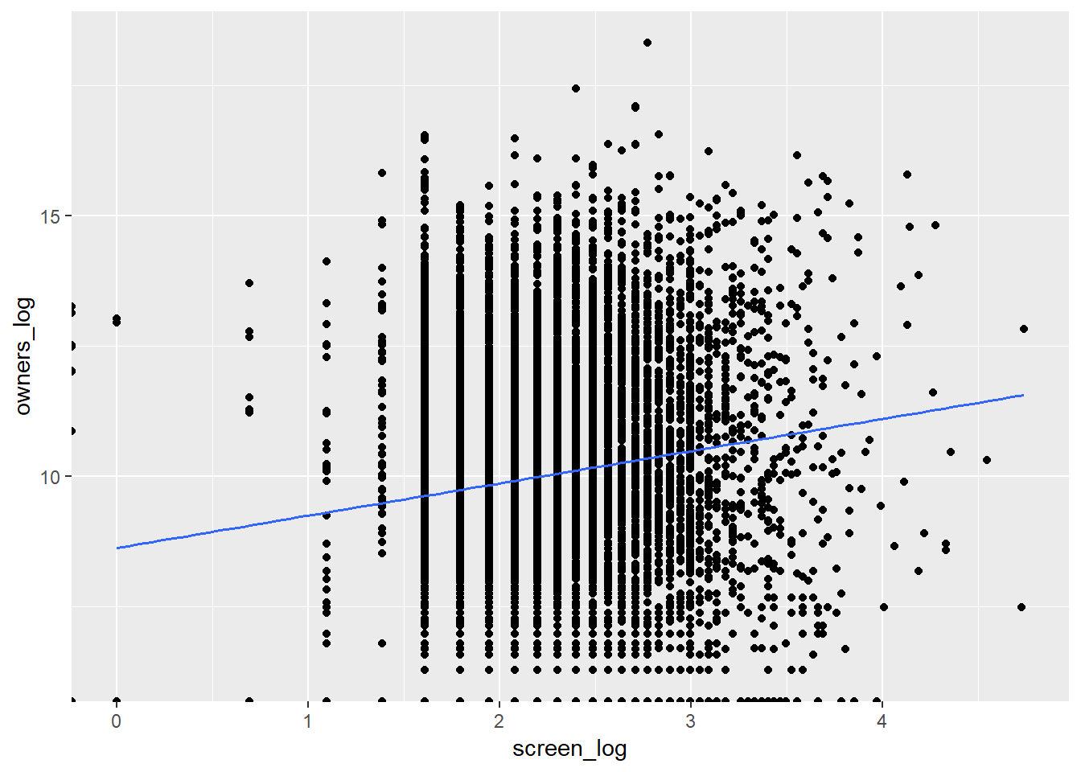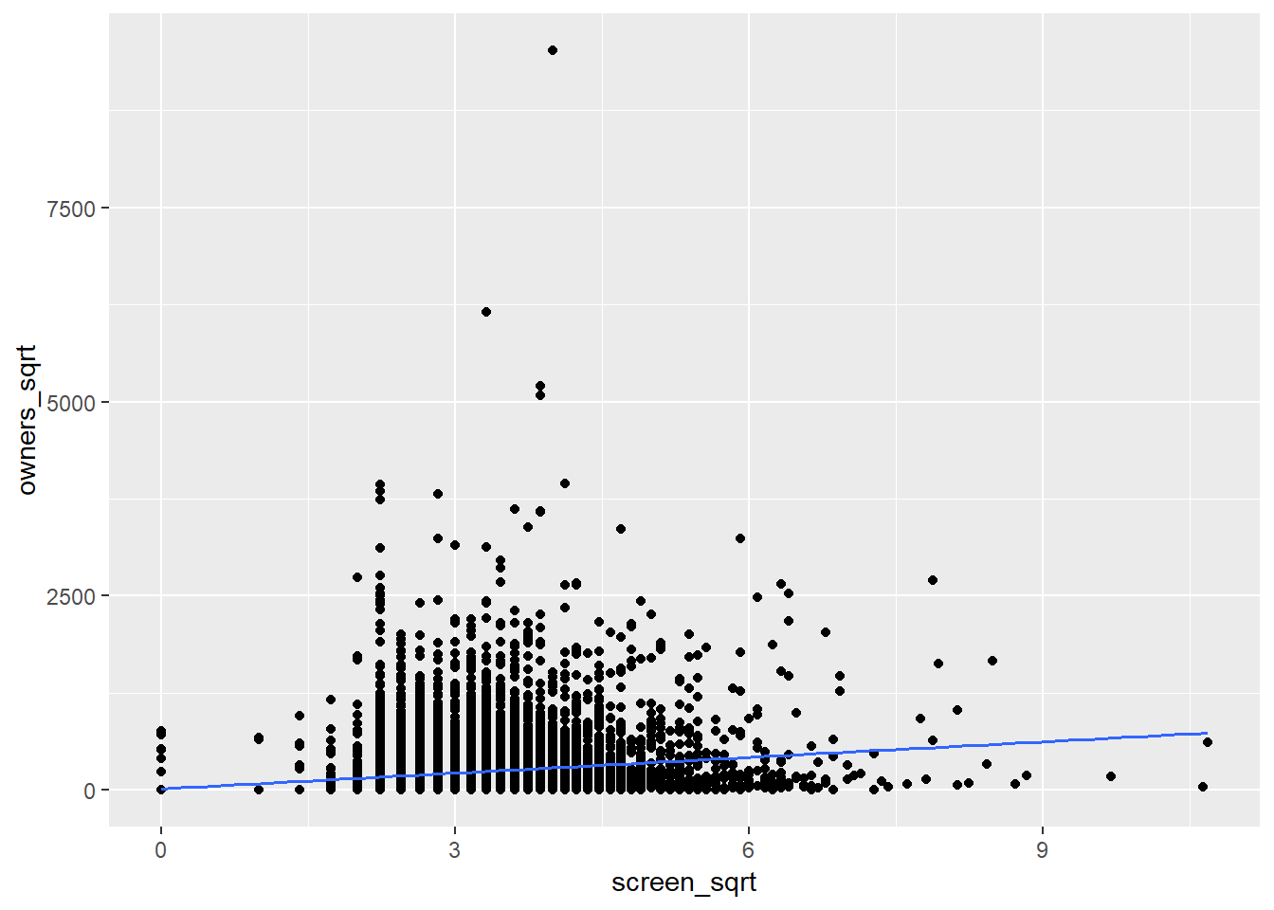

While it’s still not easy to see, but there appears to be linear relationship between our variables. Due to the nature of how log works, when I “logged” my variables, records with zeroes in them were removed. Since zero values do matter to us (free games or games without screenshots), I decided to proceed with using square roots of our variables.

To use linear regression on our variables, there are four main assumptions we need to verify: Is it indeed a linear relationship between the variables? Are the residuals normally distributed? Is there constant variance around the regression line at each x-location? Is the data independent (random)?

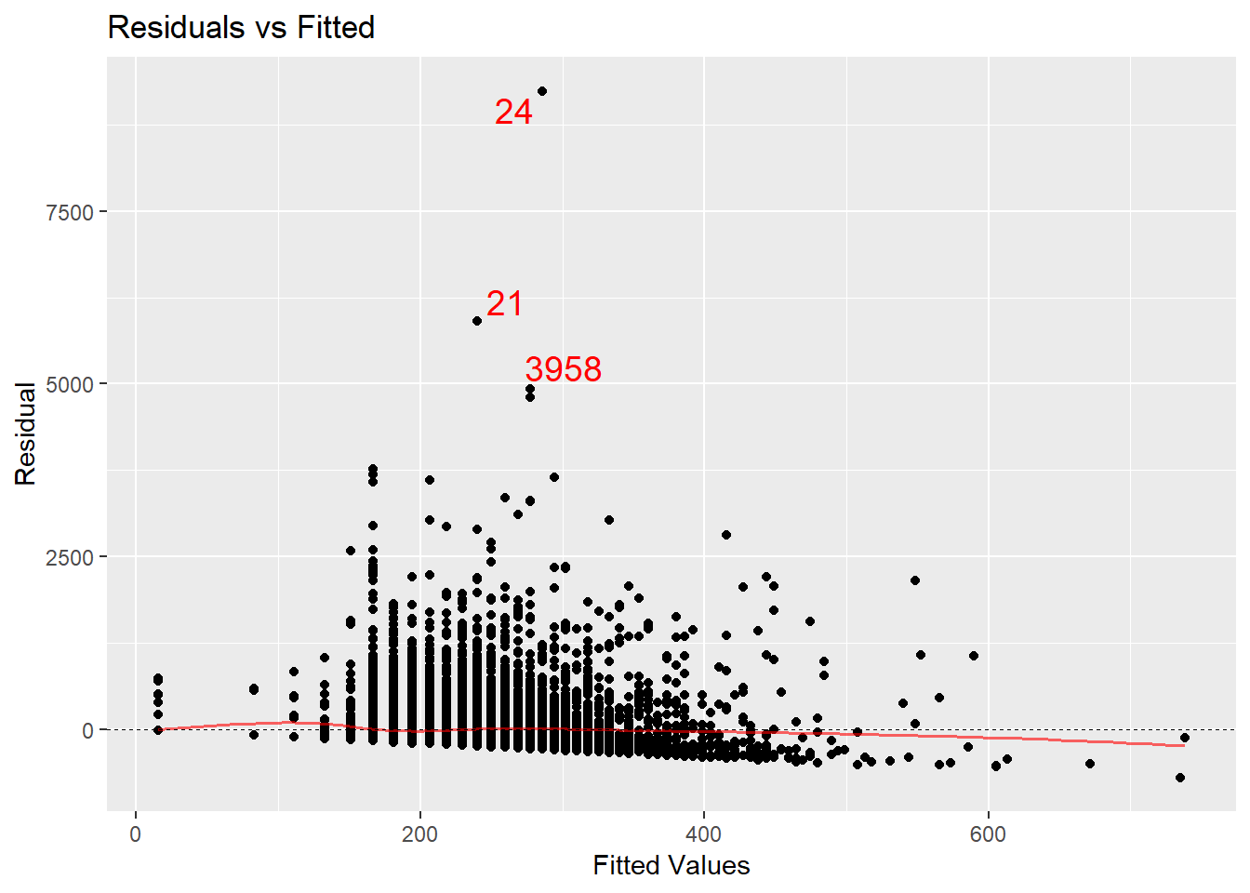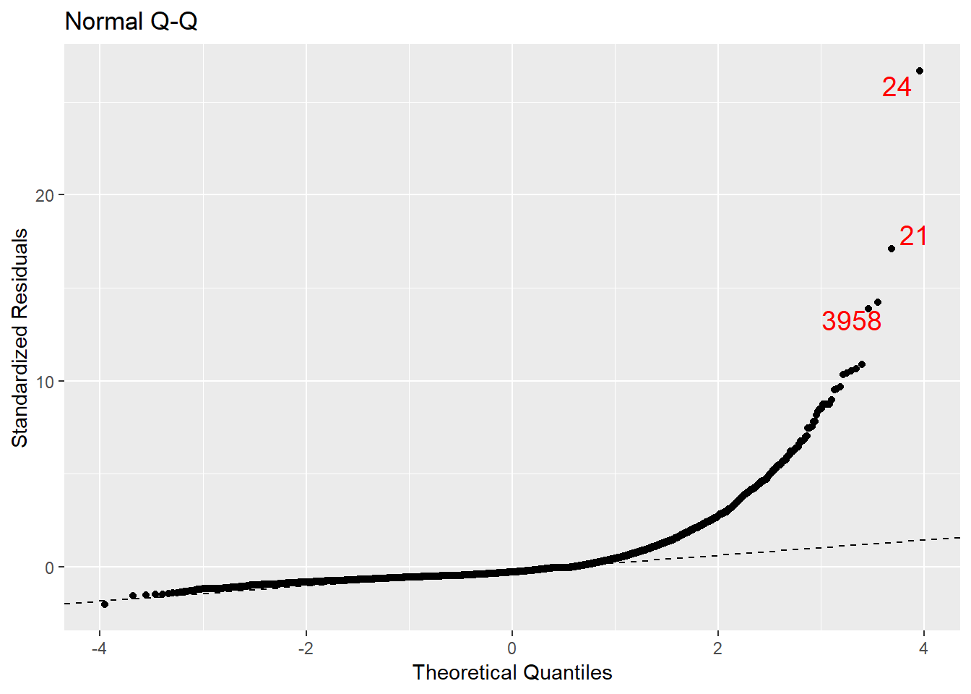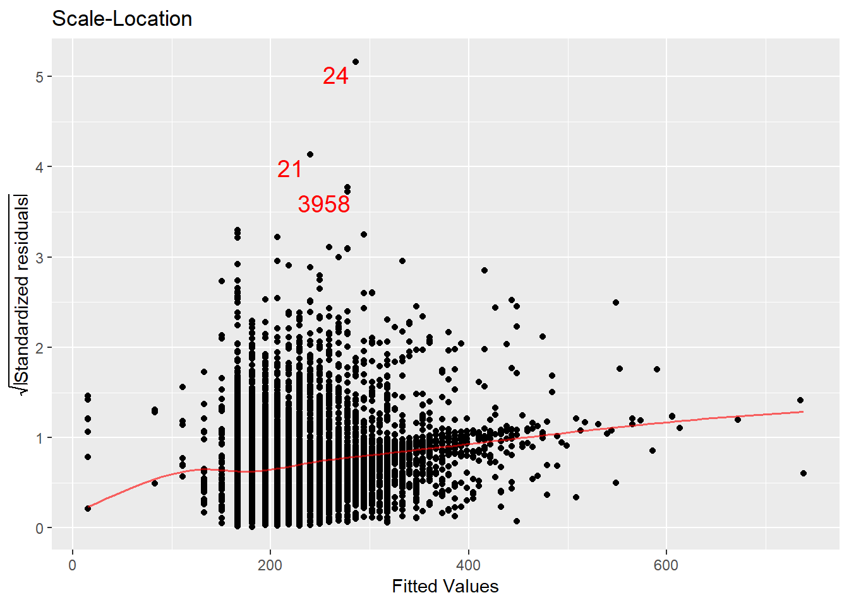

From the “Residuals vs Fitted” plot we can see that it’s indeed a linear relationship, since the red line is mostly horizontal. In terms of normality of residual distribution, from “Normal Q-Q” plot we can see that it’s not the case. Also, from “Scale-Location” plot we can observe that there doesn’t exist a constant variance around the regression line at each x-location. Since each game is a unique thing and parameters of one game usually doesn’t depend on parameters from the other game, I will assume that our data is independent. As we can see, our data fails 2 out of 4 assumptions: normality of residual distribution and a constant variance around the regression line. Because of that regression analysis is not the ideal tool to assess the association between those variables. But since it’s the best way to do it that I know, I will proceed with it, just need to keep in mind those failed assumptions:

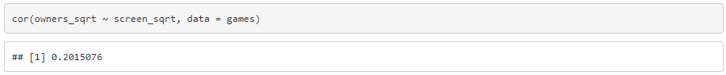

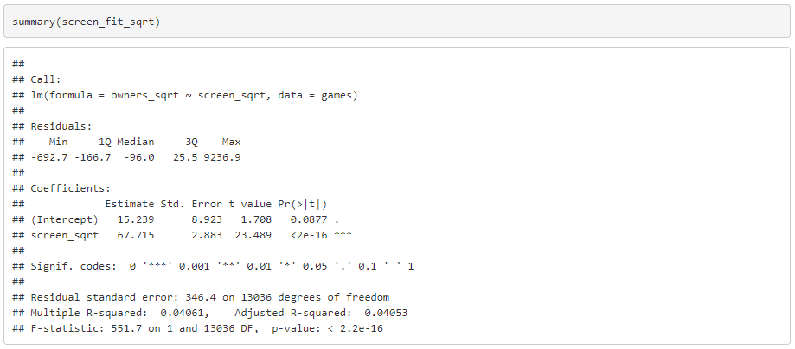

Firstly, checking correlation between variables - it’s weak (0.2). By running a summary analysis of our regression line, we can derive our linear regression formula:

y = 15.239 + 67.715 * x

owners = 15.239 + 67.715 * screenshots

Using a linear regression model for this data (square root of it) have proven to be not the best approach: it failed 2 out 4 assumptions to use linear model and does have weak correlation using this model.

***Question 3***

*“Is there an association between how many copies of the game were sold and the price of*

*the game?”*

Let’s start with a scatterplot first:

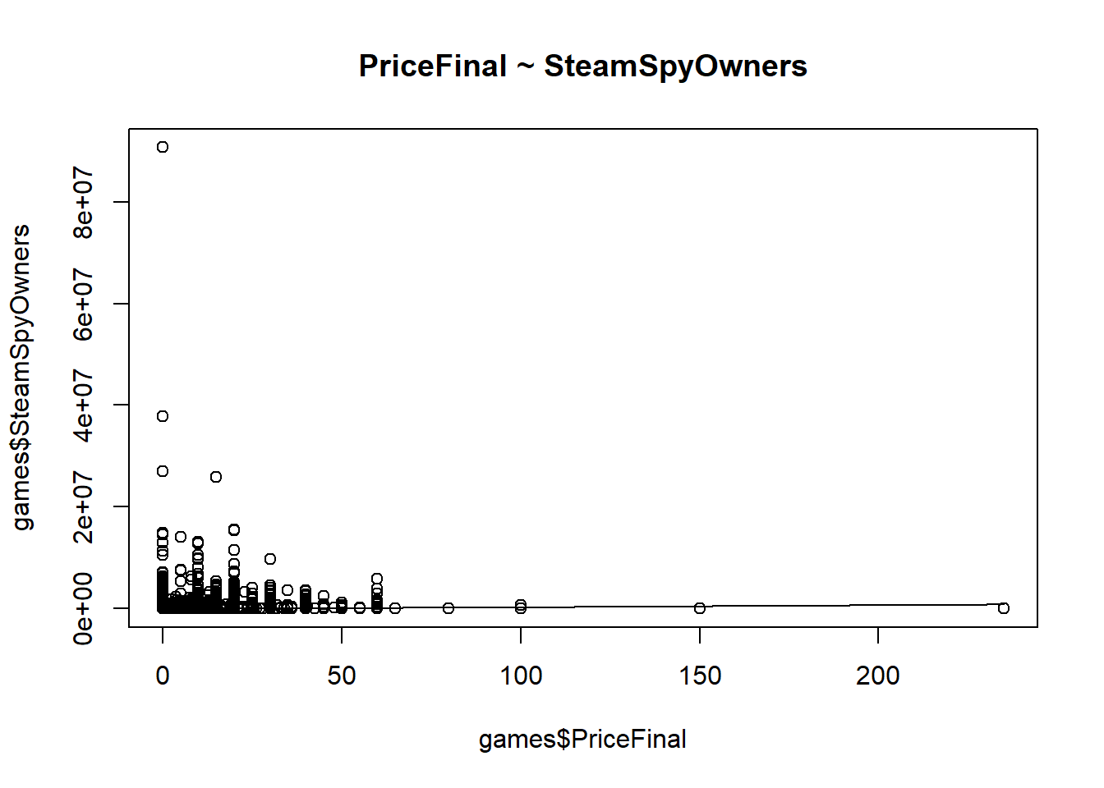

As with previous question, can’t really say much at this stage. Again, problems with outliers. Let’s graph boxplots for both the PriceFinal and SteamSpyOwners variables:

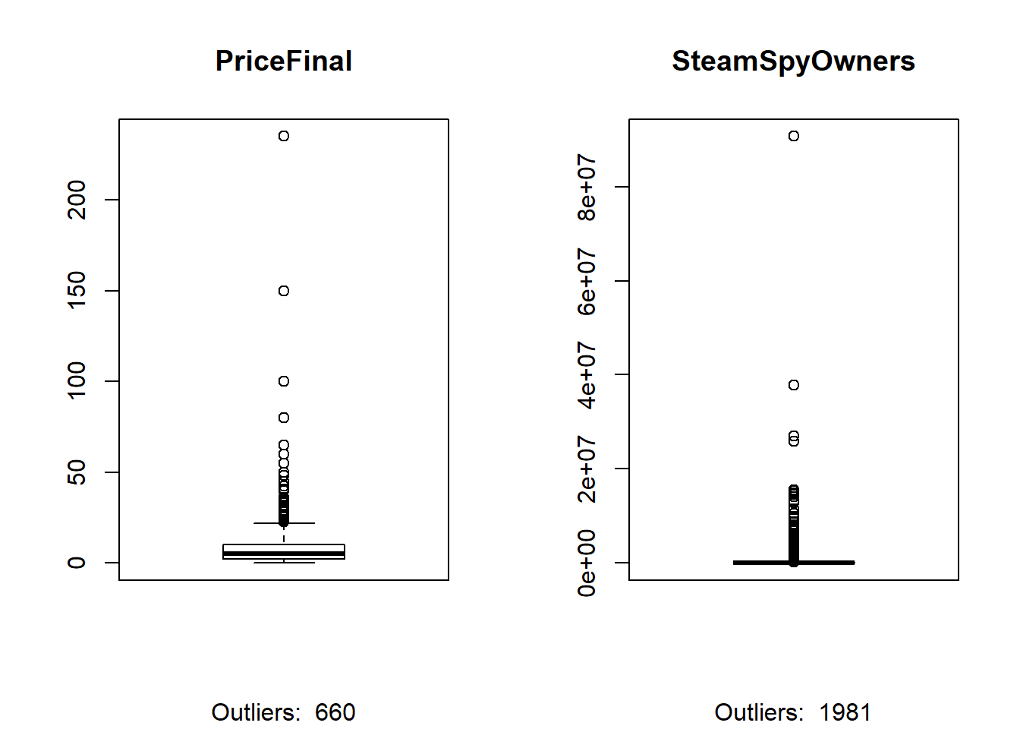

Number of outliers is like previous question. 660(around 5% of the dataset) for final price for a game, and 1981 (around 15% of the dataset) for number of owners! What is interesting, is that most games are below $25 mark, which makes sense, just never thought of it before. Before we move on to the next stage, something needs to be done about those outliers.

Since in question (2) we determined that values of 0 do matter to us, we will try to square root our data to help linearize the relationship between final price of the game and its owner count:

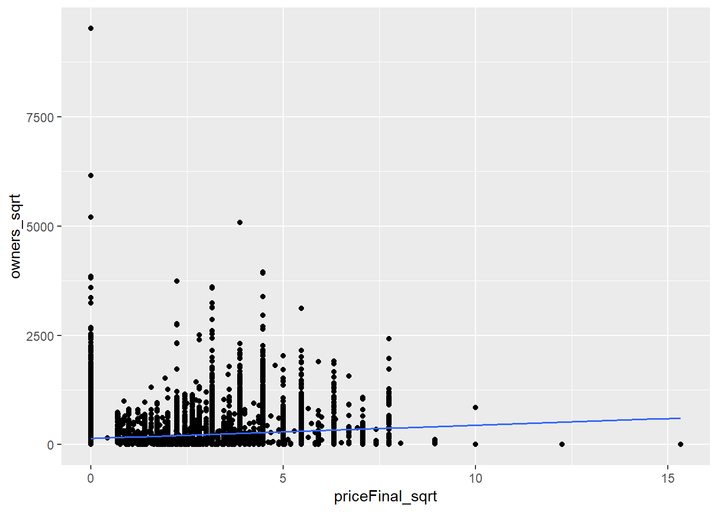

Linear relationship is basically impossible to spot at this point. Let’s check our assumptions for using a linear regression model: Is it indeed a linear relationship between the variables? Are the residuals normally distributed? Is there constant variance around the regression line at each x-location? Is the data independent (random)?

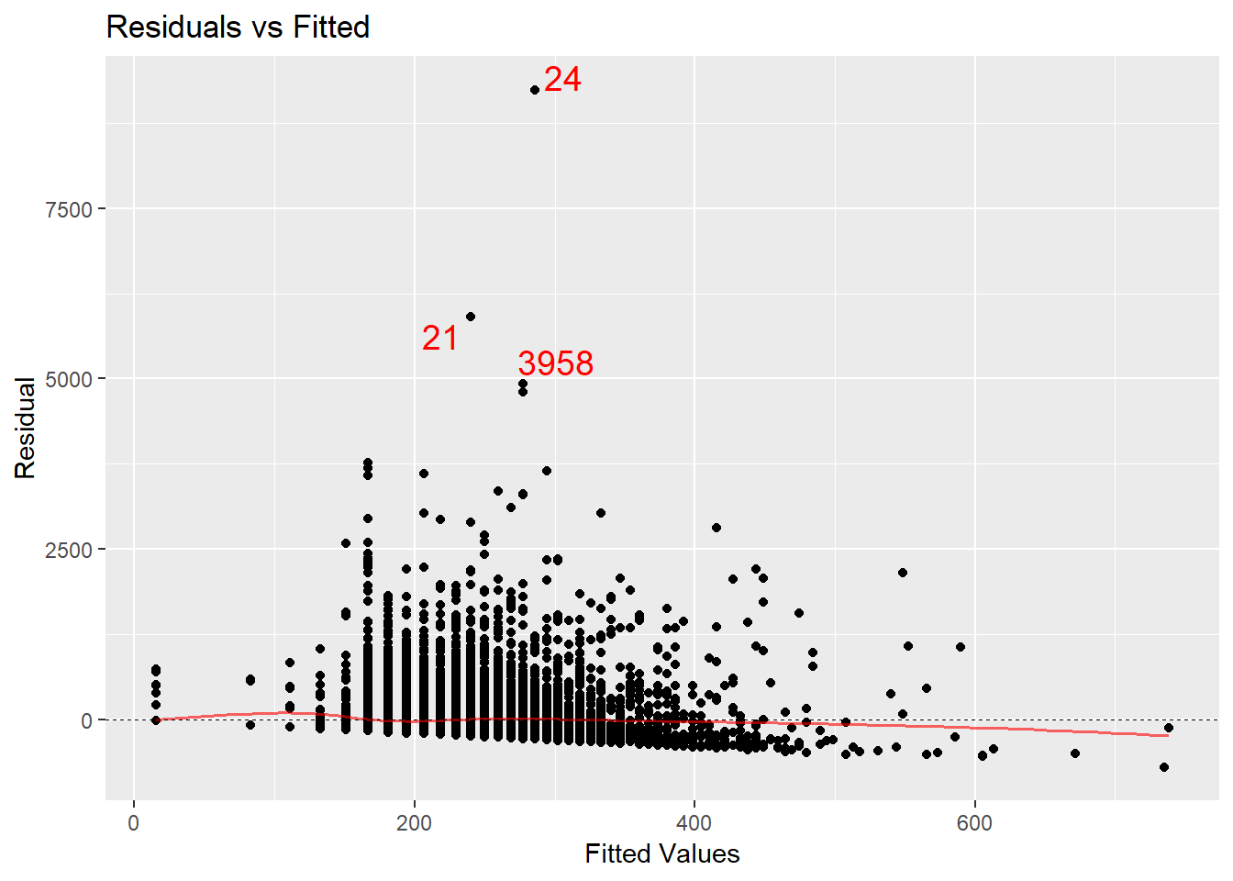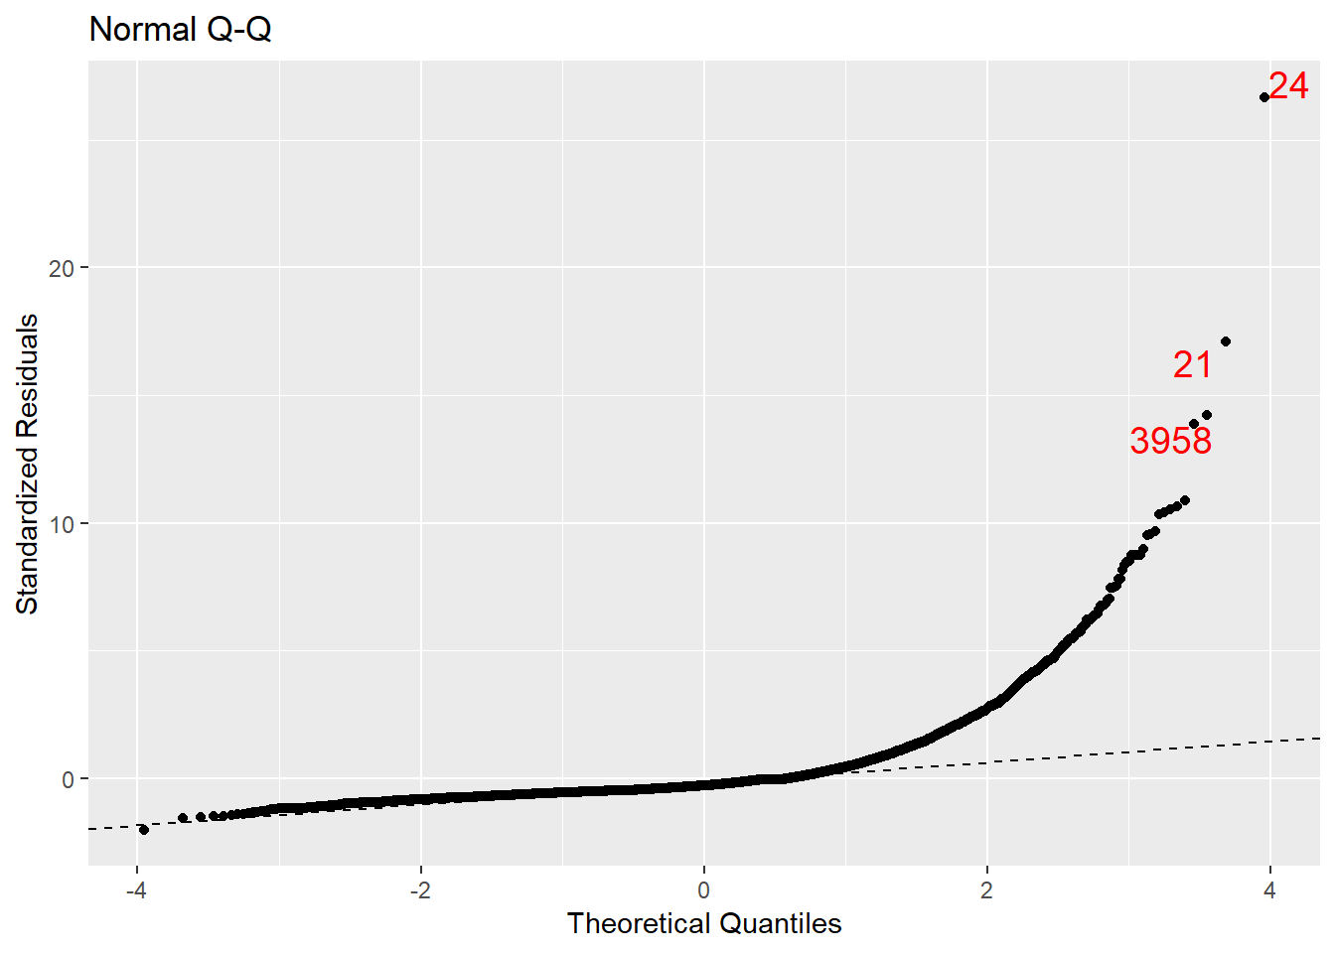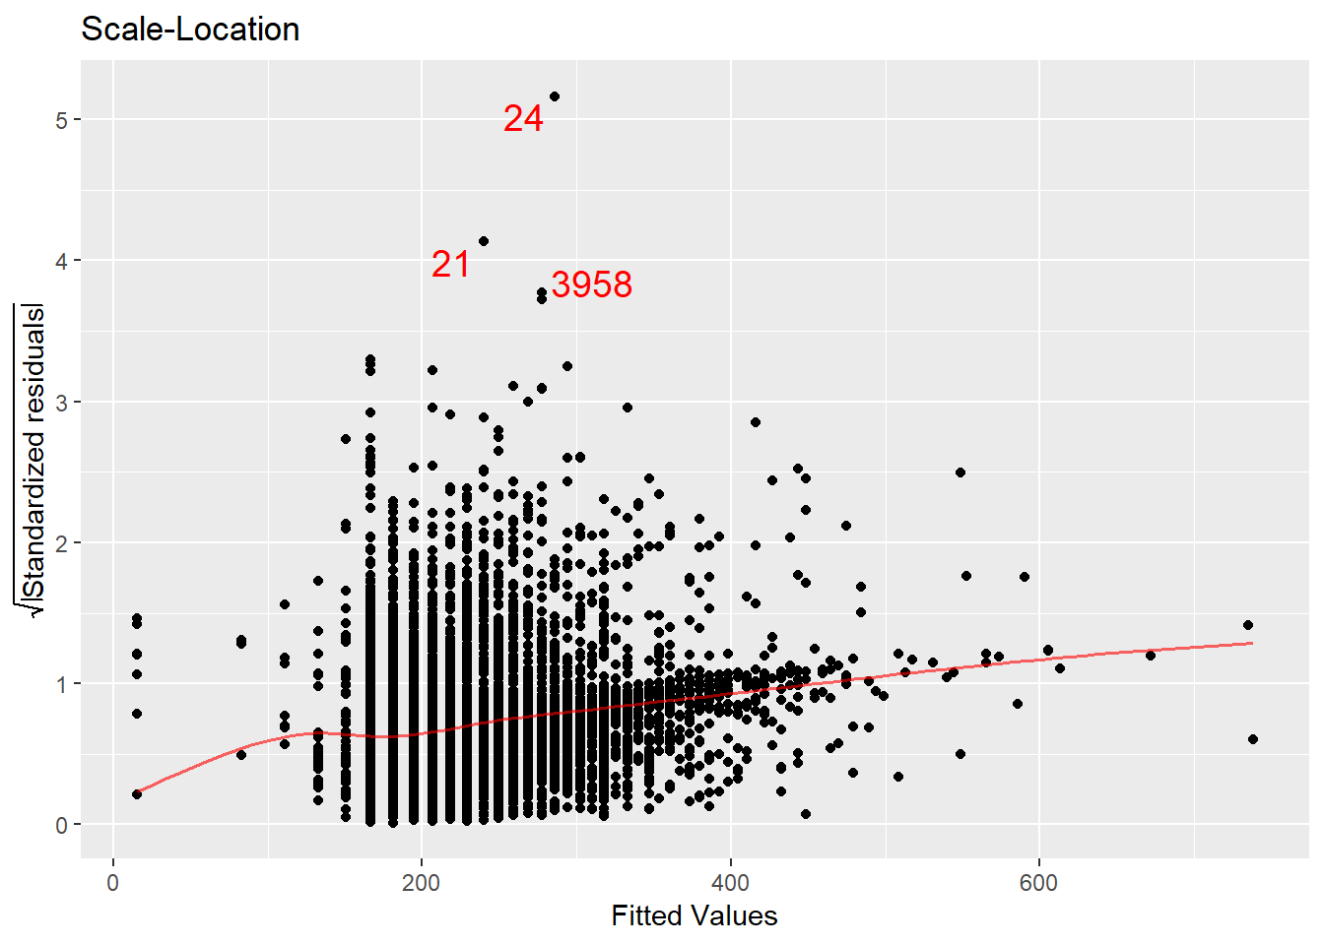

The same situation this time: data is independent and it’s a linear relationship (Residuals vs Fitted), but residuals are not normally distributed (Normal Q-Q) and there is no constant variance around the regression line at each x-location (Scale-Location). Thus, this time around, linear regression model is also not the best fit for these variables. Oh well, let’s see what kind of correlation we will get and what is the equation for linear regression:

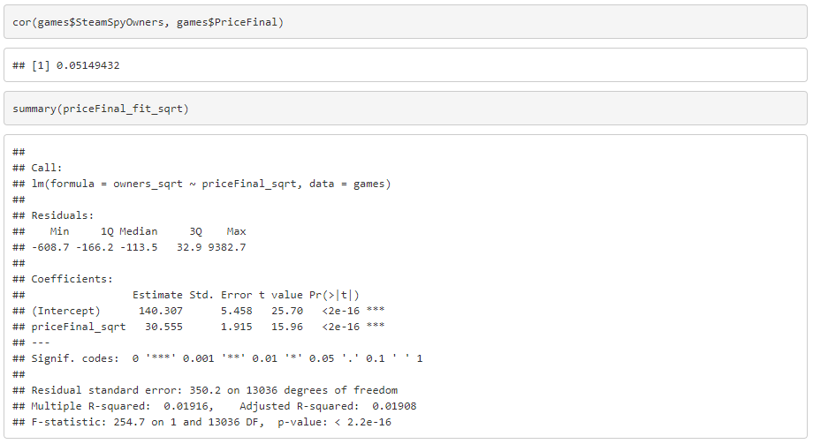

For this question, using linear regression model, correlation is basically non-existent at 0.05 and our linear regression equation is:

y = 140.3 + 30.5 * x

owners = 140.3 + 30.5 * priceFinal

Similarly to question (2), using linear regression for this data (square root of it) is a bad fit, especially this time - correlation is basically non-existent. Unfortunately, this is the best model for the situation I know at the moment, most likely there are better ways to assess this question.

**Conclusions**

***Major findings***

There are definitely some significant differences in summary statistics between

games that have Metacritic score and which don’t (at least for number of owners, game’s price, game’s number of recommendations, and achievements count). Unfortunately, in terms of questions (2) and (3): while the linear regression model is the best approach I know, it was not sufficient for use with the data at hand, thus no major findings were found.

***Limitations/Weaknesses***

Some information was practically impossible to find, for instance how many

video games existed at a certain time on PC platform. Availability of old games,

game emulators to play games from different platforms, and fan-made/hobbyist

games also raise some questions in terms of what games should be included.

Data required some more advanced statistical approaches to analyze the data

appropriately.

Apparently, there are not that many research studies on video game parameters

and how they relate to such things as Metacritic score and game sales (at least I

couldn’t find a good one on that subject)

***Follow up research questions for future study***

A nice thing to do would be to assess some of the questions in this study by using

more advanced statistical techniques (better model), so that I might find something interesting in this data.

Another thing would be to try and answer question (1) in a more serious (or systematic, with clear results) manner, if it’s possible.

Also, since I haven’t seen a study on how many games there are in total on PC

platform, might be interesting to investigate this question more in depth.

**Works Cited**

[1] About Metacritic score, <https://www.metacritic.com/about-metascores>

FAQ, <https://www.metacritic.com/faq#item18>

[2] “Using Steam data to tell if your game will sink or swim”, <https://venturebeat.com/2017/06/28/using-steam-data-to-tell-you-if-your-game-will-sink-or-swim/>

[3] “Steam – What’s your Game?”,<https://nycdatascience.com/blog/student-works/web-scraping/steam-whats-game/>

[4] “What’s in the Name? Data analysis of 5,820 Steam Games”, <https://gamedevelopment.tutsplus.com/articles/whats-in-a-name-data-analysis-of-5820-steam-games--cms-30101>

[5] “Understanding your game through data”, <https://galyonk.in/understanding-your-game-through-data-8b09ca93ec11>

[6] Steam data, <https://github.com/CraigKelly/steam-data>

[7] Steam (software), <https://en.wikipedia.org/wiki/Steam_(software)>

[8] Edwards, Cliff (November 4, 2013), “Valve Lines Up Console Partners in Challenge to Microsoft, Sony”

[9] Bailey, Dustin (March 22, 2018), “With $4.3 billion in sales, 2017 was Steam’s biggest year yet”

[10] Answer to “How many video games exist?” on Quora by John Mcmillagan, <https://www.quora.com/How-many-video-games-exist>